**Azure AI ML Business Process Automation Lab using Power Platform and Azure cognitive services**

GIT URL : <https://github.com/CSALabsAutomation/azure-ai-ml-bpa-using-powerapps-lab>

**Prerequisites**

1. Create azure resources using the ARM Template

URL : <https://github.com/CSALabsAutomation/azure-ai-ml-bpa-using-powerapps-lab/blob/main/environments/env1/template.json>

1. Download “BPA_Template_v2_Current.zip” file
2. Download “Calculation_email_approval_template-BPA_20230111144219.zip” file
3. Download “SendNotificationToFinanceTeam_template_20230112095308.zip” file
4. Download Training Documents
5. Download Test Documents
6. Download Postman collection files

**Importing Power Apps template and creating AI Model**

1. Open new tab and go to <https://make.preview.powerapps.com/>
2. Select “Apps” from the left navigation and Click on “Import Canvas app

1. Upload the “.zip” file then click on “Import”.

1. Click on “Open App”

1. Click on “Get Started”

1. App will be open with pre built pages and controls

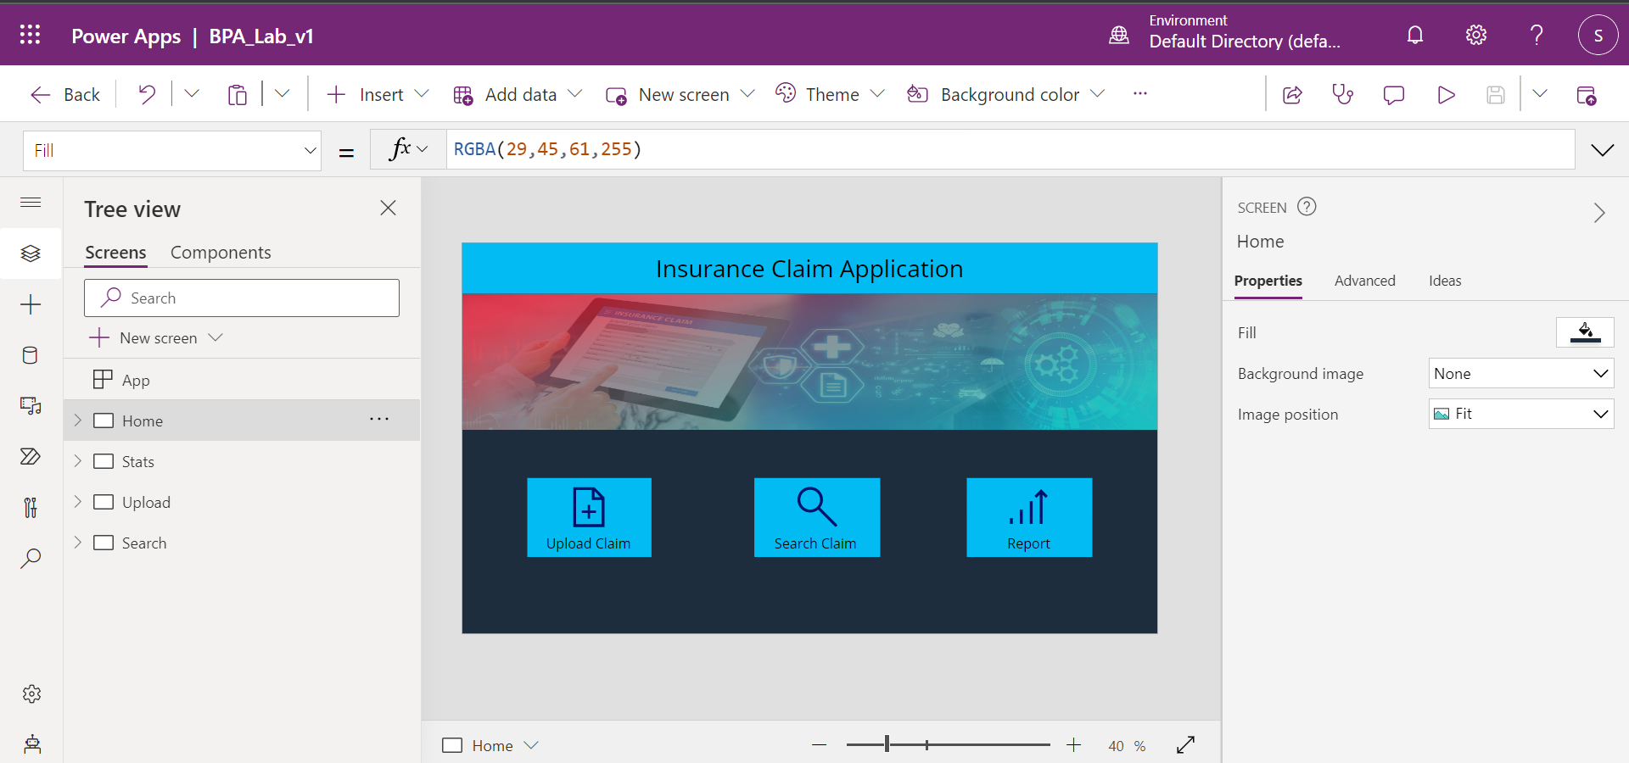

1. Click on Upload in the Tree view pane.

1. Select “Form Processor ” control on the screen. Click on “Select Model” from the properties section. We need to create a new model here for the app.

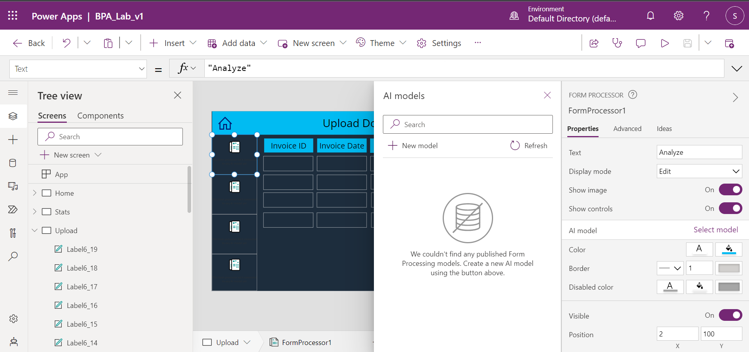

1. Selecting “New Model” will open a new tab. Select “Extract information from invoices”.

1. Select “Document processing custom model” then “Get started”.

1. Select “Structured documents” and click on Next

1. Click on add button to add fields. Select Field and click next. Enter “InvoiceID” and click on Done.

1. Repeat same for below fields.

* InvoiceDate
* Category
* ClaimType
* Amount

After adding all the fields click on next

1. Click on New collection.

1. Click on + Icon and then on “Add documents”. Upload 5 training documents that you have downloaded before from Training documents folder in the prerequisites.

Click on “Upload 5 documents“. After documents get uploaded click on “Done” and then “Next”

1. Now after document get uploaded, you need to mark the fields in the documents.

Mark invoiceID (INV00X) on document and select InvoiceID as field.

Mark Date on document and select InvoiceDate as field

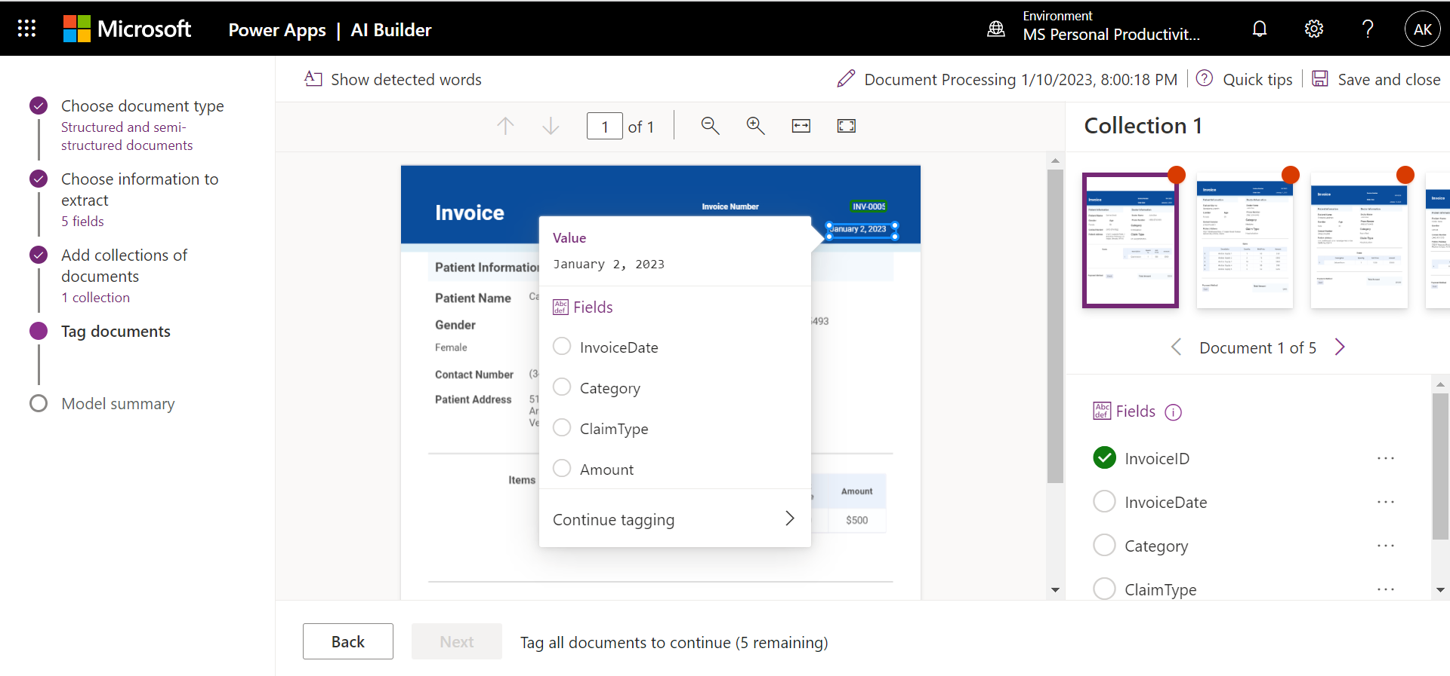

Mark Category data on document and select Category as field

Mark Claim type data on document and select ClaimType as field

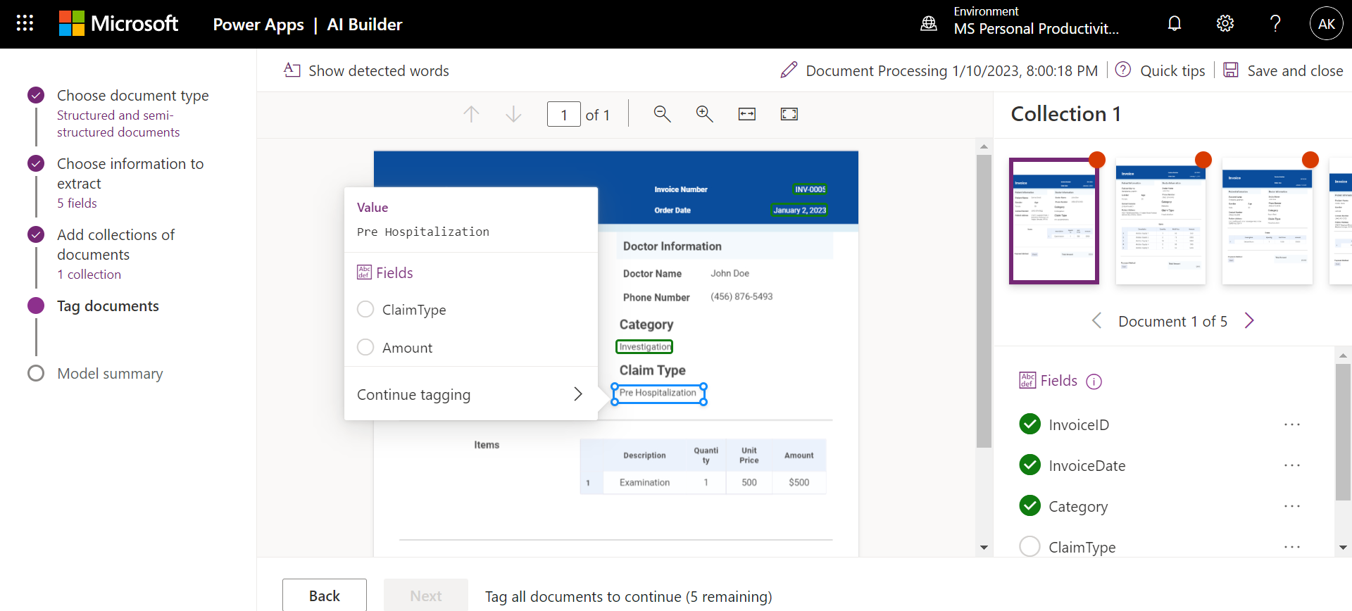

Mark Amount data on document and select Amount as field

1. Now repeat same for other 4 documents and click on Next.

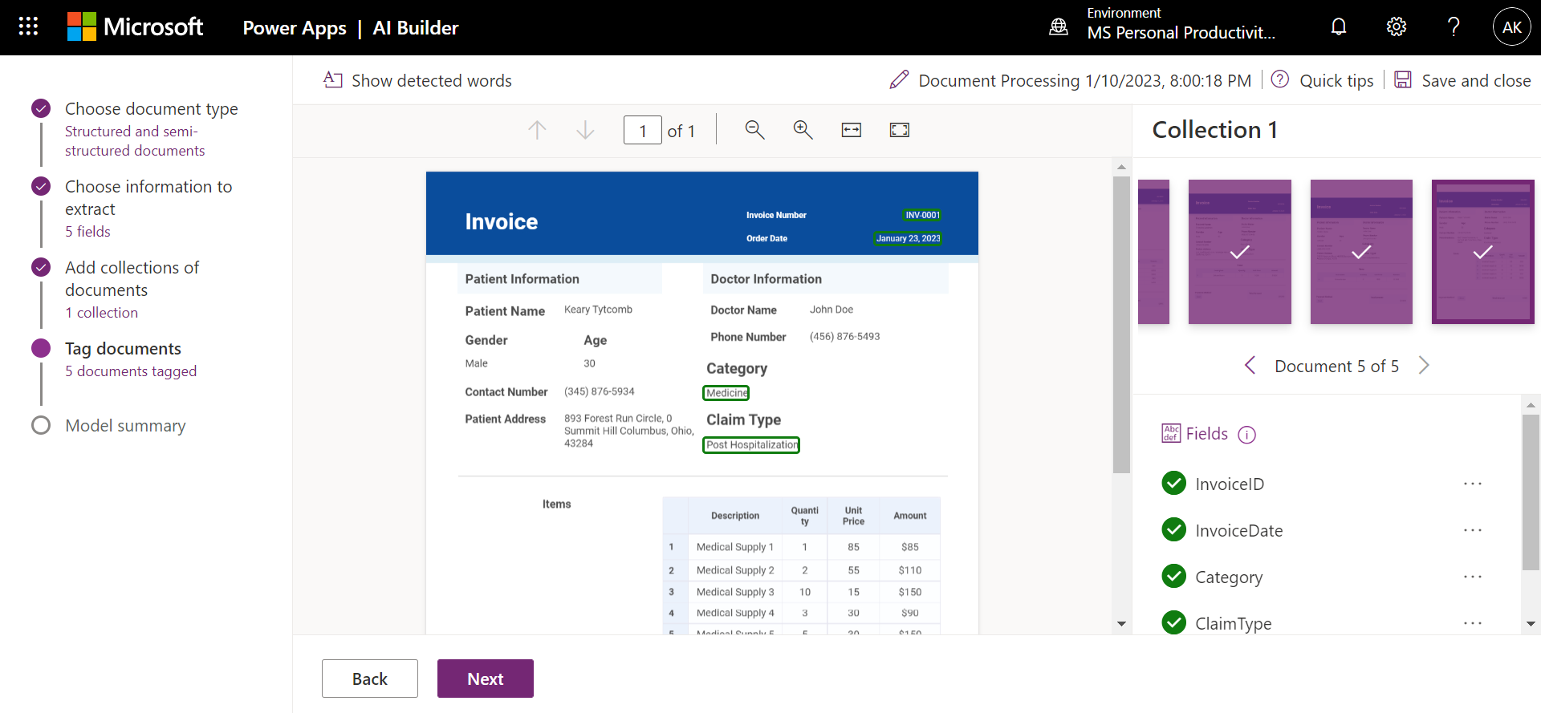

Now Rename the Model to “BPAInvoiceModel” then click on Train and wait for 2 mins.

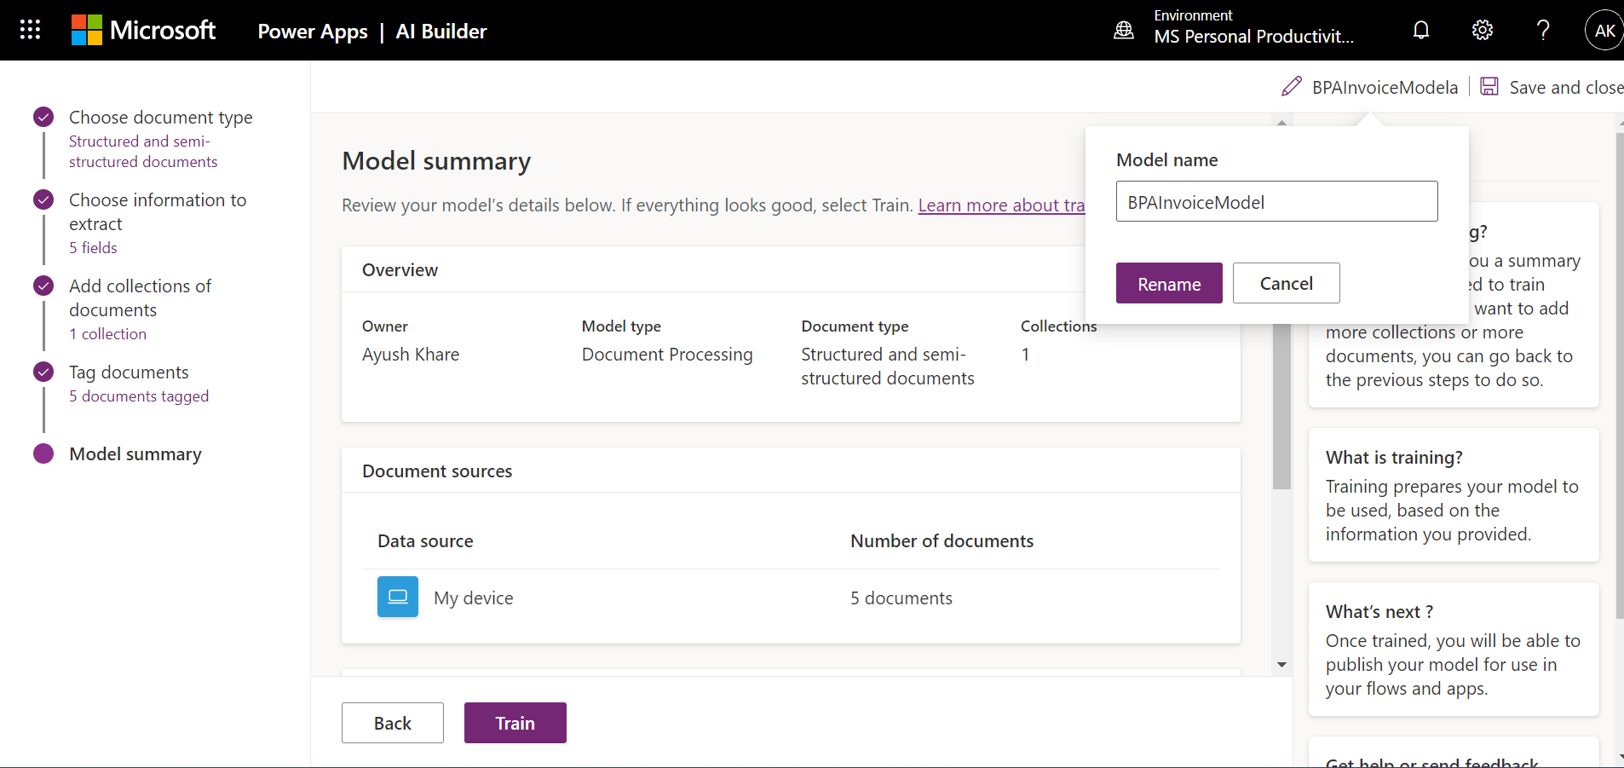

1. Click on “Publish”

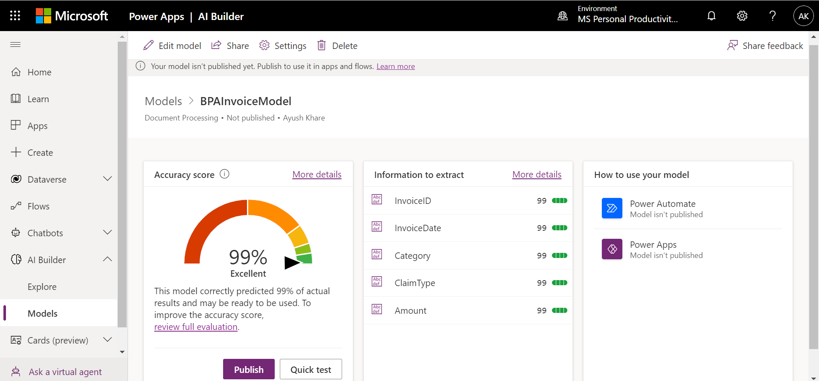

1. Go back to PowerApp tab where app is open. And select the newly created AI Model.

Assign same AI Model to other 3 Form Processor control.

1. Go to Power Automate section in left navigation and select Add flow. Then create from blank. Procced with the actions as mentioned in the attached template.

Note : instructions to be provided to the user for creating the flow not template.

Git URL : <https://github.com/CSALabsAutomation/azure-ai-ml-bpa-using-powerapps-lab/blob/main/environments/env1/Artifacts/Calculation_email_approval_template-BPA_20230111144219.zip>

Flow Name : Calculation_email_approval

**Configuring Azure Cognitive Search**

1. ACS will be created by the ARM template. Instruction to be provided for creating the index

Add below fields.

* InvoiceID
* InvoiceDate
* Category
* ClaimType
* Amount

Select all the attributes:

**Creating Custom Connectors using the Postman collection**

1. Download the Postman collection from the Git Repo.

Git Repo URL :

Search : <https://github.com/CSALabsAutomation/azure-ai-ml-bpa-using-powerapps-lab/blob/main/environments/env1/Artifacts/ACSBPA_Search.postman_collection.json>

Upload : <https://github.com/CSALabsAutomation/azure-ai-ml-bpa-using-powerapps-lab/blob/main/environments/env1/Artifacts/ACSBPA_Upload.postman_collection.json>

Note : Update the API Key and the ACS URL after downloading the file

1. Open Power Apps and create a new custom connector using downloaded postman files.

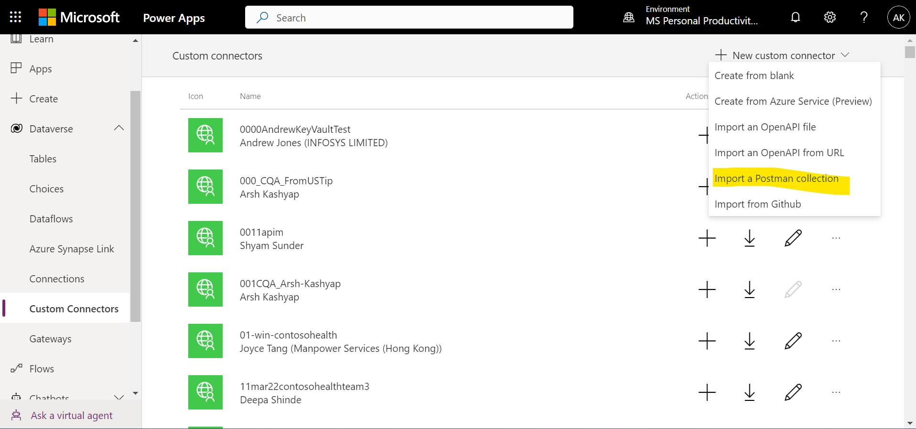

1. Connector Upload

* Import
* In Body provide Title to each parameter and set Is Required as “No”

* Test

1. Connector search

* Import
* Update the response using the sample import and provide Title to each parameter

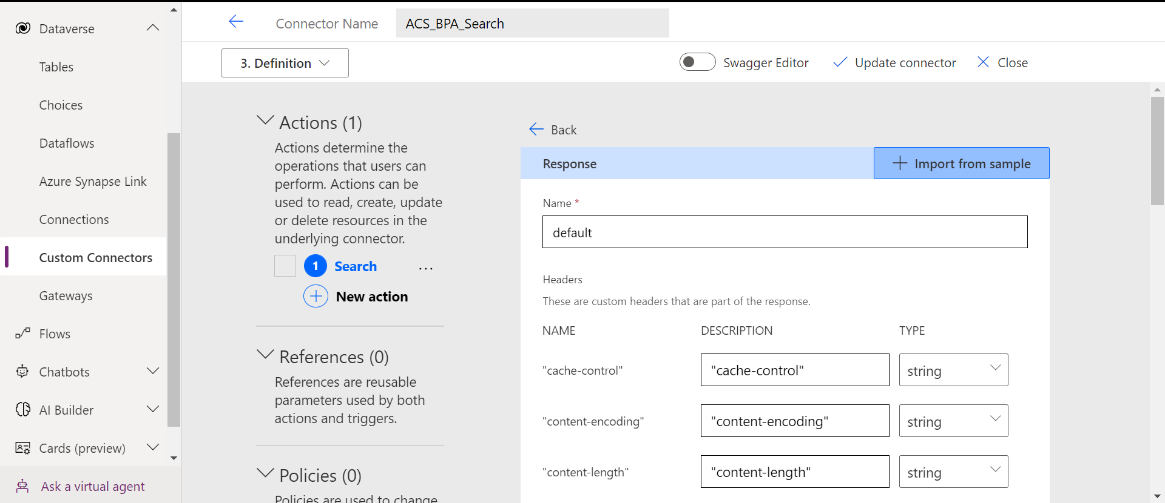

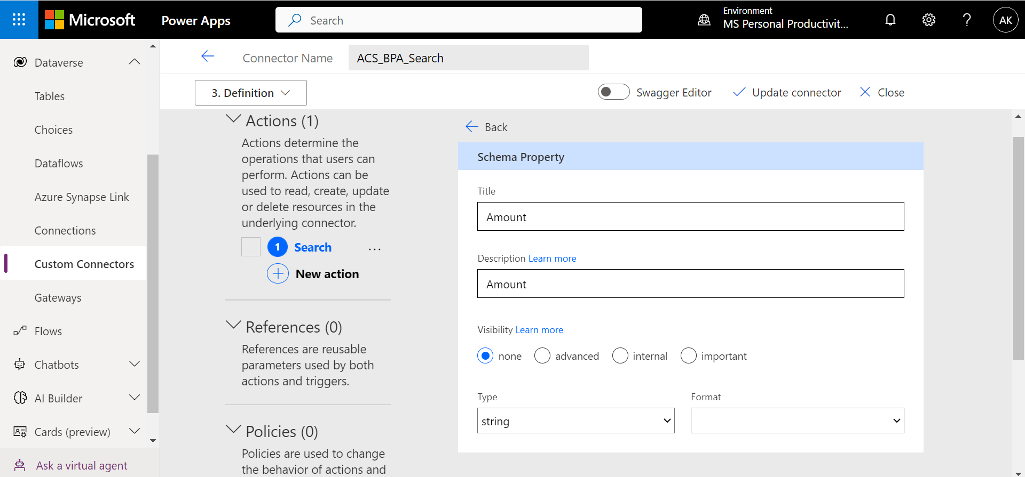

* Test

1. Goto PowerApp Upload screen again and Use below code for OnSelect of the Submit button.

Set(varAmount1,Right(Label6_1.Text,Len(Label6_1.Text) - 1));

Set(varAmount2,Right(Label6_5.Text,Len(Label6_5.Text) - 1));

Set(varAmount3,Right(Label6_6.Text,Len(Label6_6.Text) - 1));

Set(varAmount4,Right(Label6_7.Text,Len(Label6_7.Text) - 1));

Set(vartab,Table(

{'@search.action':"upload",id:"1", InvoiceID: Label6.Text, InvoiceDate: Label6_8.Text, Category: Label6_9.Text, ClaimType: Label6_10.Text, Amount: varAmount1},

{'@search.action':"upload",id:"2", InvoiceID: Label6_2.Text, InvoiceDate: Label6_11.Text, Category: Label6_14.Text, ClaimType: Label6_15.Text, Amount: varAmount2},

{'@search.action':"upload",id:"3", InvoiceID: Label6_3.Text, InvoiceDate: Label6_12.Text, Category: Label6_16.Text, ClaimType: Label6_17.Text, Amount: varAmount3},

{'@search.action':"upload",id:"4", InvoiceID: Label6_4.Text, InvoiceDate: Label6_13.Text, Category: Label6_18.Text, ClaimType: Label6_19.Text, Amount: varAmount4}

));

ACSBPA_Upload.Upload({value:vartab});

Calculation_email_approval.Run(varAmount1,varAmount2,varAmount3,varAmount4);

Notify("Claim Submitted",NotificationType.Success);

Navigate(Home);

1. Add the data sources from upload and search custom connector.

**Search screen setup in Power Apps**

1. Open the Search screen and Use below code for OnSelect of the Search button

ClearCollect(

HotelCol,

ACSBPA_Search.Search(

"2021-04-30-Preview",

TextInput1.Text,

"application/json",

"UfRV0s0Ej3nGijCfFepzMCNbYmNFBWAEbeyPgt4xDSAzSeBIbNjl"

).value

);

1. Set HotelCol as the data source for the Gallery.

**Configuring Subscriber Power Automate and Event Grid**

1. Login to the *Power Automate* portal and click *Get Started*.

Flow Template URL :

<https://github.com/CSALabsAutomation/azure-ai-ml-bpa-using-powerapps-lab/blob/main/environments/env1/Artifacts/SendNotificationToFinanceTeam_template_20230112095308.zip>

[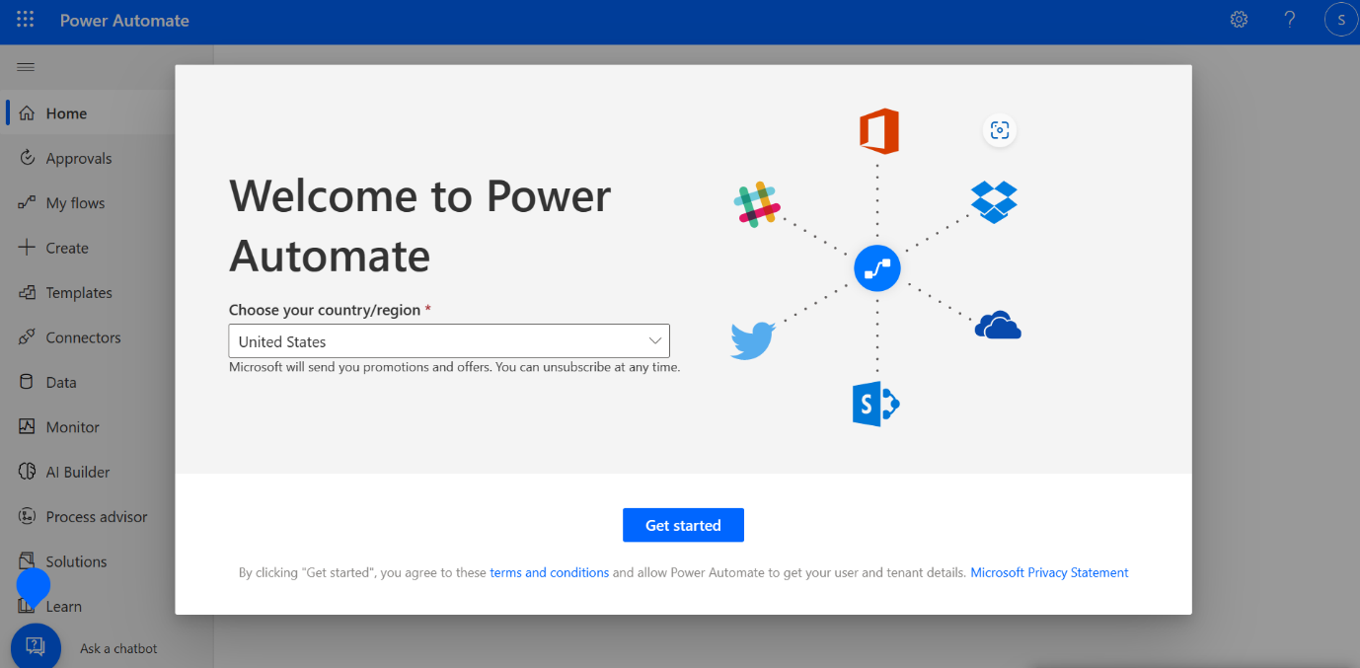](https://github.com/CSALabsAutomation/azure-ai-ml-bpa-using-powerapps-lab/blob/main/steps/event_grid_subscription/assets/01.png)

1. Click *My flows* from the left navigation bar.

[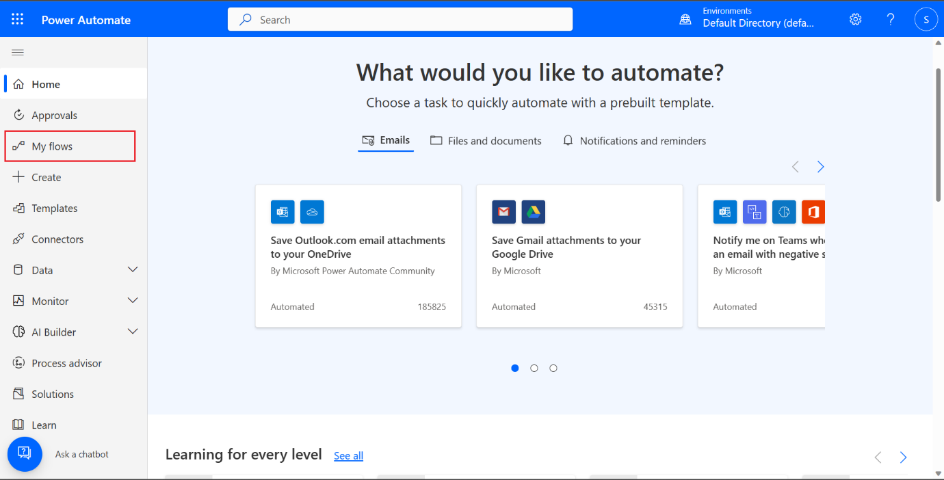](https://github.com/CSALabsAutomation/azure-ai-ml-bpa-using-powerapps-lab/blob/main/steps/event_grid_subscription/assets/02.png)

1. Create a new flow by clicking *New flow*. From the dropdown, choose *Automated cloud flow*.

[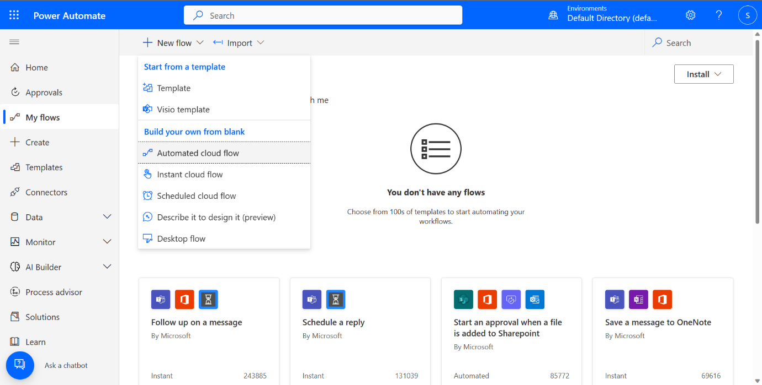](https://github.com/CSALabsAutomation/azure-ai-ml-bpa-using-powerapps-lab/blob/main/steps/event_grid_subscription/assets/03.png)

1. A dialog appears, click *Skip* which takes you to the flow editor.

[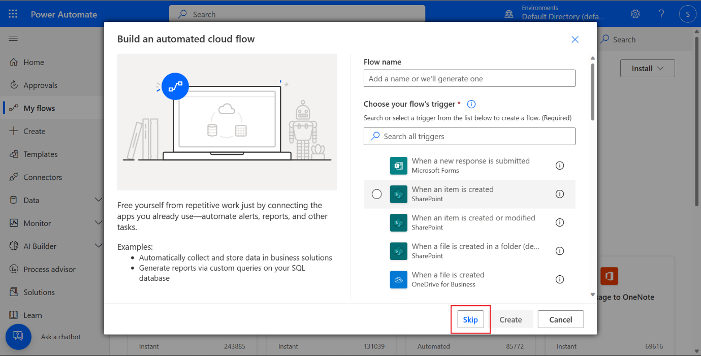](https://github.com/CSALabsAutomation/azure-ai-ml-bpa-using-powerapps-lab/blob/main/steps/event_grid_subscription/assets/04.png)

1. You can name your flow. Set *SendNotificationToFinanceTeam* as the name to your flow.

[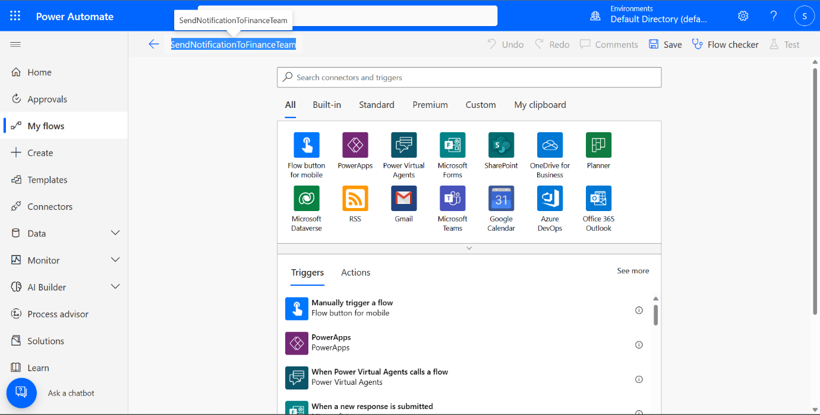](https://github.com/CSALabsAutomation/azure-ai-ml-bpa-using-powerapps-lab/blob/main/steps/event_grid_subscription/assets/05.png)

1. Search **http** and select *When an HTTP request is received* trigger.

[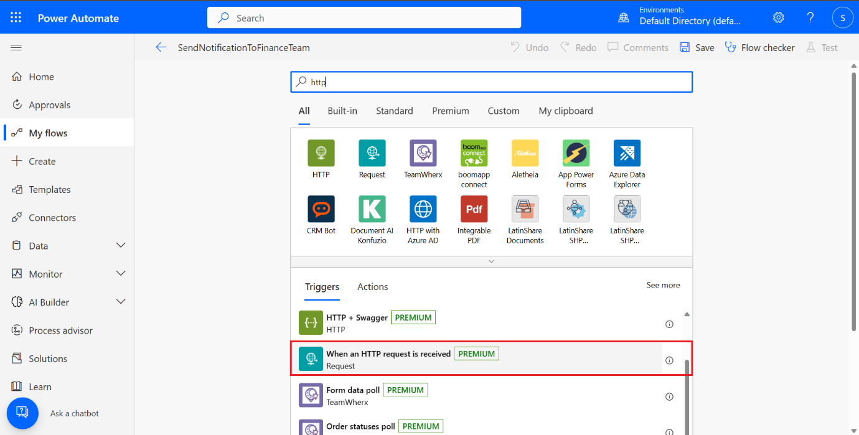](https://github.com/CSALabsAutomation/azure-ai-ml-bpa-using-powerapps-lab/blob/main/steps/event_grid_subscription/assets/06.png)

1. Add your next step by clicking *New step*. Search **parse json** and select the *Parse JSON* action.

[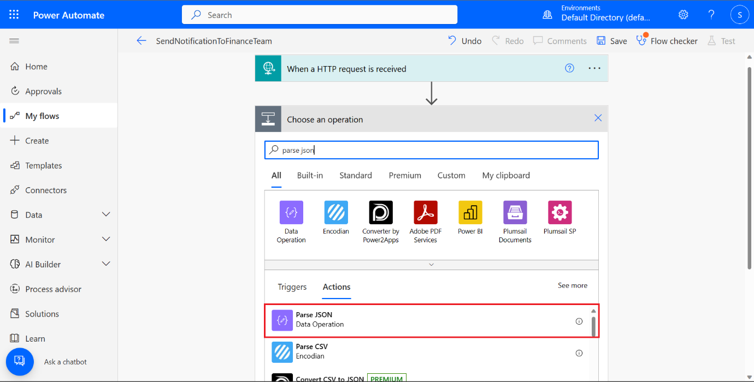](https://github.com/CSALabsAutomation/azure-ai-ml-bpa-using-powerapps-lab/blob/main/steps/event_grid_subscription/assets/07.png)

1. Set the *Content* to *Body*, which is one of the output of the previous step that you can find under the *Dynamic content* tab. **Paste the schema provided as provided below :**

{

"type": "array",

"items": {

"type": "object",

"properties": {

"id": {

"type": "string"

},

"subject": {

"type": "string"

},

"eventType": {

"type": "string"

},

"data": {

"type": "object",

"properties": {

"RaisedAmount": {

"type": "string"

},

"AppovedAmount": {

"type": "string"

}

}

},

"dataVersion": {

"type": "string"

},

"metadataVersion": {

"type": "string"

},

"eventTime": {

"type": "string"

},

"topic": {

"type": "string"

}

},

"required": [

"id",

"subject",

"eventType",

"data",

"dataVersion",

"metadataVersion",

"eventTime",

"topic"

]

}

}

[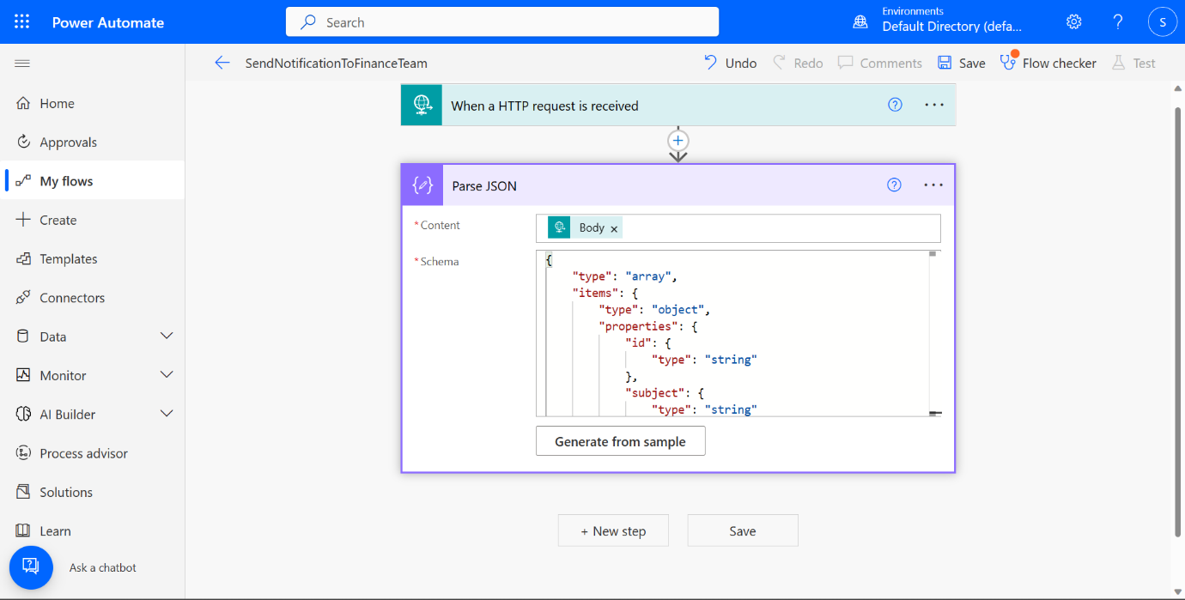](https://github.com/CSALabsAutomation/azure-ai-ml-bpa-using-powerapps-lab/blob/main/steps/event_grid_subscription/assets/08.png)

1. Add your next step by clicking *New step*. Search **post message** and select the *Post message in a chat or channel* action.

[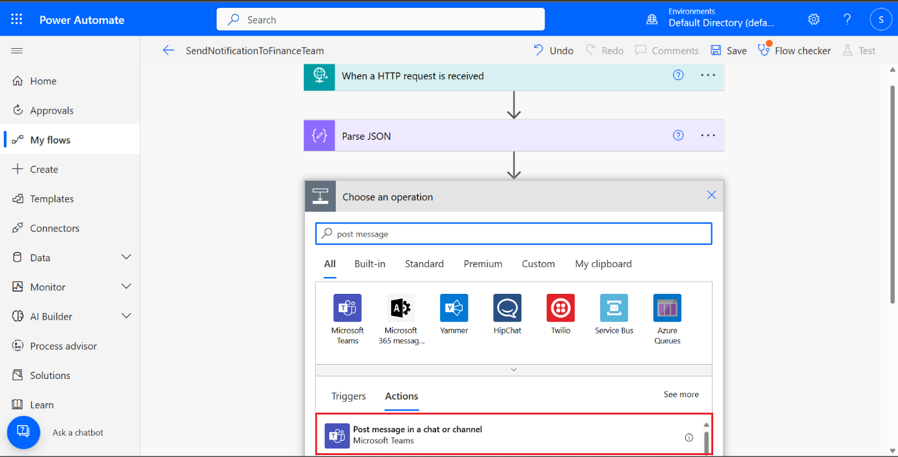](https://github.com/CSALabsAutomation/azure-ai-ml-bpa-using-powerapps-lab/blob/main/steps/event_grid_subscription/assets/09.png)

1. Click *Sign in* to create a connection to Teams. Use your personal/work account to sign in and send a teams message to Finance Team.

[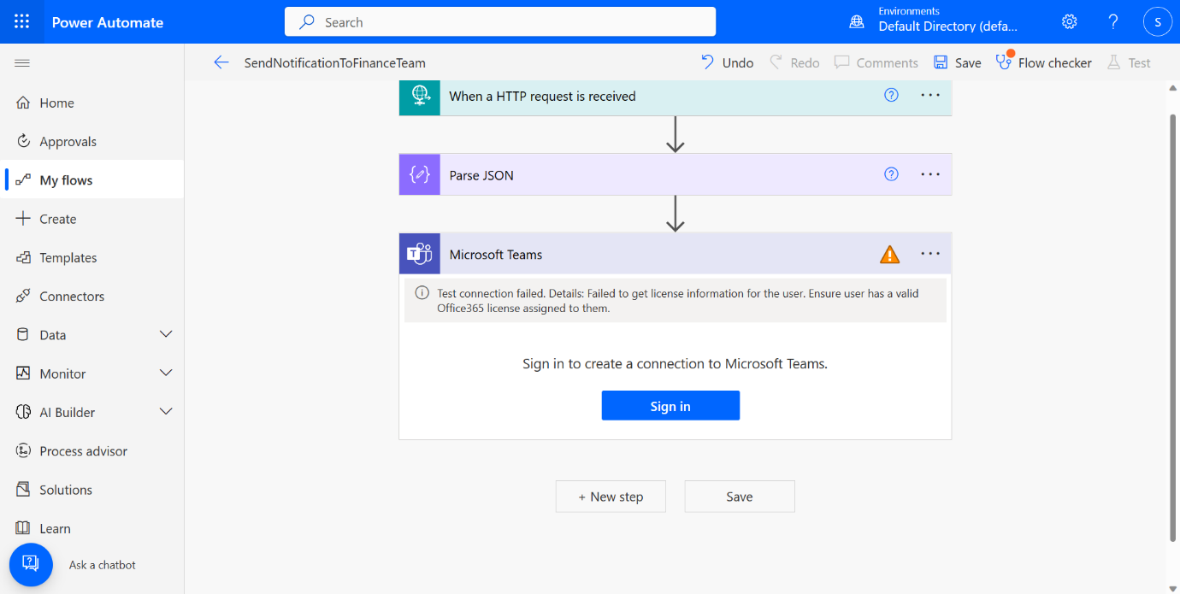](https://github.com/CSALabsAutomation/azure-ai-ml-bpa-using-powerapps-lab/blob/main/steps/event_grid_subscription/assets/10.png)

1. Copy the HTTP request URL

1. Open azure portal, goto Event Grid Topic (resource created by ARM template) and create new Event Subscription
2. Name the event subscription and use Webhook as event type.

Provide the HTTP request url in the Subscriber Endpoint.

**Run and test the App**

1. Save and Publish the app then click on Run Button
2. Goto Upload screen and upload 4 files from the Test documents using 4 Form Processing control and click on Submit Button.

1. Approve the Claim from Teams or Outlook.
2. Go to Search screen and click on search button.

**Power BI Report Creation**

1. Copy the Search URL from ACS

[https://bpa-acs.search.windows.net/indexes/invoicedoc/docs?api-version=2021-04-30-Preview&search=*](https://bpa-acs.search.windows.net/indexes/invoicedoc/docs?api-version=2021-04-30-Preview&search=*)

1. Download and open Power BI Desktop
2. GetData 🡪 Web
3. Use Search URL from ACS and headers

Replace the App Key

1. After Data is loaded generate below report.

Refer PBIX file

<https://github.com/CSALabsAutomation/azure-ai-ml-bpa-using-powerapps-lab/blob/main/environments/env1/Artifacts/claim.pbix>

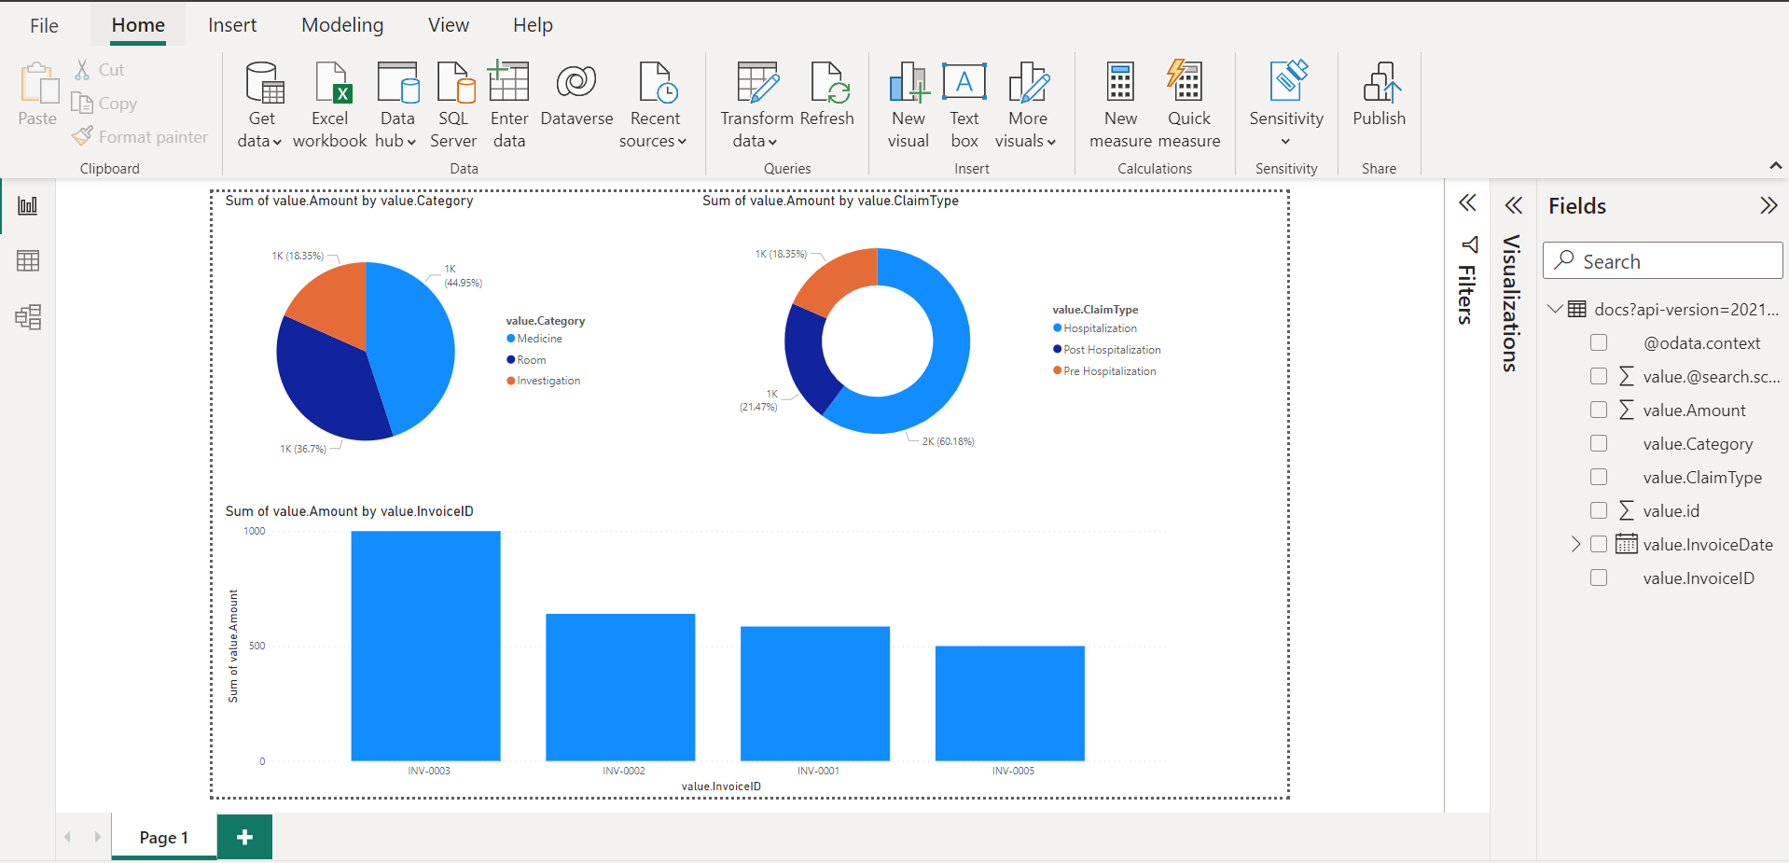

1. Publish to Power BI Cloud

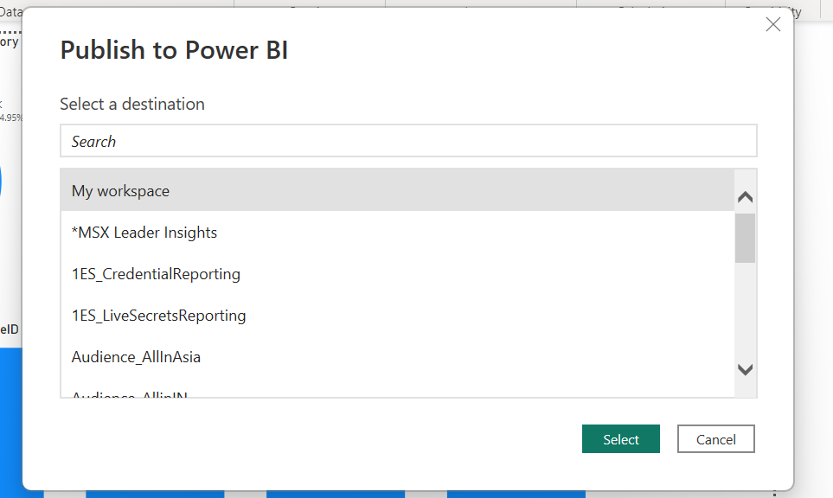

1. Click on “Open ‘claim.pbix’ in Power BI”

1. Goto -> File-> Embed Report -> Website or Portal

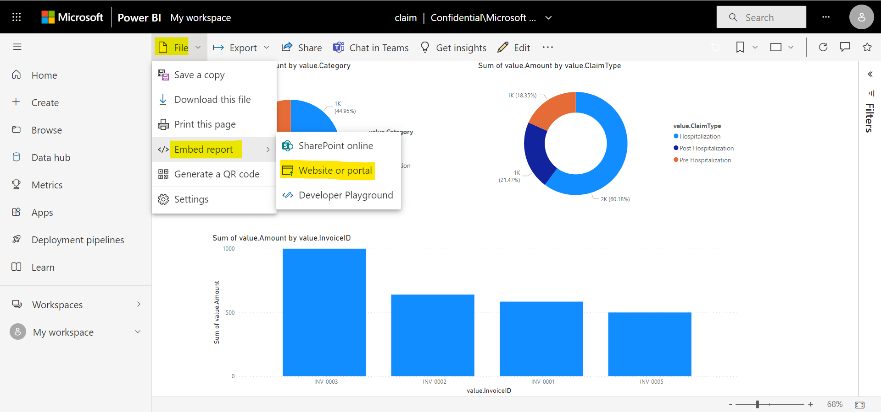

1. Copy the link to embed the content

**Power BI Report Integration in Power Apps**

1. Open Power Apps portal and Report Screen
2. Insert Power BI Tile

1. Select Power BI Tile and update the “TileUrl” with the embed URL copied above from the Power BI

1. Save and Publish the App

**Pending Tasks**

1. Validations
2. Instructions